Clase Program (Program Class):

Main(): Main method, the main entry point of the program. It displays a menu to the user and manages diary options.

Clase Diario (Diary Class):

entries: A private field that stores a list of Entry objects, representing all diary entries.

AddEntry(string, string): A public method to add a new entry to the diary, taking a question and an answer as arguments.

ShowDiary(): A public method that displays all diary entries in a readable format on the console.

SaveDiaryToFile(string): A public method that lets the user save diary entries to a CSV file, taking a filename as an argument.

LoadDiaryFromFile(string): A public method that lets the user load diary entries from an existing CSV file, taking a filename as an argument.

SearchEntries(string): A public method that allows the user to search for entries in the diary containing a specific keyword.

Clase Entrada (Entry Class):

Date: A private field representing the date of an entry.

Question: A private field storing the question associated with an entry.

Response: A private field storing the user's response or comment for an entry.

GetFormattedEntry(): A public method that returns a formatted representation of an entry, including the date, question, and response.

Clase Generador de Preguntas (PromptGenerator Class):

prompts: A private field storing a list of possible questions or topics for diary entries.

GeneratePrompt(): A public method that randomly generates a question from the available set of prompts and returns the generated question.

Exceeding recuirements:

Improve the process of saving and loading to save as a .csv file that could be opened in Excel

Additionally, it implements a timer (autoSaveTimer) for automatically saving the diary every 5 minutes.

my_diary.csv is a data file that acts as the persistent store for journal entries

……………………………………………………………………………………………………………………………………………

System: Provides essential tools for C#.

System.Collections.Generic: Helps organize and manage data, like your diary entries.

System.IO: Allows saving and loading data from files.

System.Linq: Facilitates searching and filtering information in your entries.

System.Timers: Automates periodic saving to prevent data loss.

[.NET API browser | Microsoft Learn](https://learn.microsoft.com/en-us/dotnet/api/?view=net-7.0)

This link shows where I got information to understand the methods and classes related to using System.IO, System.Timers, and using System.Linq.

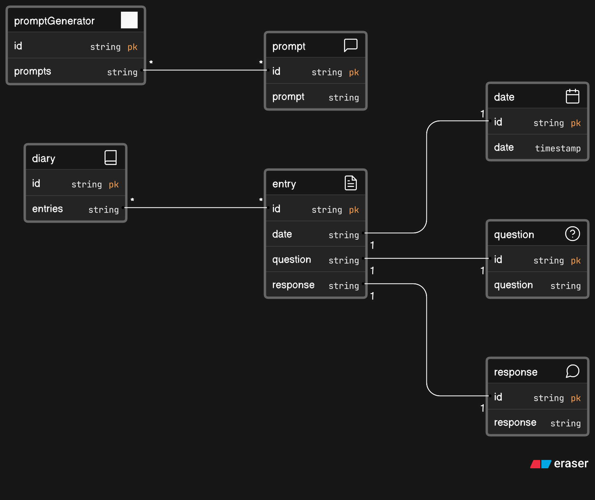

+-----------------------------------+

| Program |

+-----------------------------------+

| - Main() |

+-----------------------------------+

|

v

+-----------------------------------+

| Diary |

+-----------------------------------+

| - entries: List<Entry> |

+-----------------------------------+

| + AddEntry(string, string) |

| + ShowDiary() |

| + SaveDiaryToFile(string) |

| + LoadDiaryFromFile(string) |

| + SearchEntries(string) |

| |

| +---------------------------------+

| | Entry |

| +---------------------------------+

| - Date: DateTime |

| - Question: string |

| - Response: string |

+-----------------------------------+

| + GetFormattedEntry(): string |

| |

| +---------------------------------+

| | PromptGenerator |

| +---------------------------------+

| - prompts: List<string> |

+-----------------------------------+

| + GeneratePrompt(): string |

+-----------------------------------+